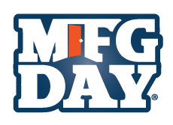
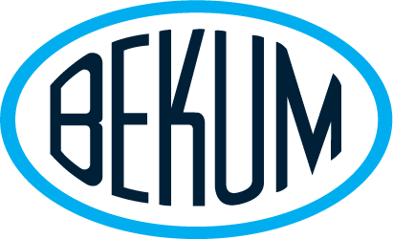
News Advisory from

For Immediate Release Contact: Narine Manukova
September 30, 2020 517-490-8232, manukovanarine@gmail.com

VIRTUAL MANUFACTURING DAY 2020 AT BEKUM AMERICA
WAS A SUCCESS

Williamston, MI – Bekum America, a leading manufacturer of blow molding machinery, celebrated Manufacturing Day 2020 by virtually welcoming local high school students to its facility in Williamston. Last year in excess of 200 students joined the celebration with tours of Bekum America Facility. This year, Bekum America extended that reach by conducting a virtual tour that included machine demonstrations, presentations by Bekum employees and a walk-through of the Apprenticeship Training Center which hosts Bekum’s award-winning apprenticeship program.

“We are excited to welcome so many students to join us in celebrating Manufacturing Day in a virtual environment this year,” said Steve London, Bekum president and COO. “We plan on sharing the many opportunities and experiences of modern manufacturing and showing students the benefits of joining our industry. Despite limitations associated with COVID-19, we are confident that students will get a great overview of our facility and our industry.”

Manufacturing Day is an annual celebration promoting careers in manufacturing and addressing any misperceptions about the industry. Students will learn:

- Manufacturing uses advanced technologically, with automation, 3-D printing, robots, and screen technology,
- Manufacturers have the highest job retention in the private sector, and
- 90 percent of manufacturing workers have medical benefits.

The Bekum Apprenticeship Program works with various school districts including; the Ingham, Eaton, and Clinton County RESA, career centers, and local area high schools in Ingham, Livingston, Genesee and Oakland Counties, to identify and recruit students. Each apprentice must complete 8,000 hours of training and complete approximately 60 credit hours at Lansing Community College, working towards an associate degree. Bekum established its Apprenticeship Program in 1994. In May of 2001, according to the Department of Labor, Bekum America graduated the two youngest, active journeymen in the United States. Approximately 50 percent of Bekum's manufacturing workforce have graduated from the apprenticeship program or are currently registered in the program.

BEKUM America was established in 1979 with the mission to introduce top quality blow molding machinery, designed to produce plastic bottles, containers and other large plastic parts in the North American marketplace, via blending German design and technology with American skill and ingenuity. Bekum’s customer base includes large multi-national customers, as well as owner/operator plastic bottle manufacturers.

####

